**JRNL User Manual**

By: Saul Amster @Blarfnip

**Quick Start**

Thank you for purchasing JRNL!

Here is a quick guide for getting started using JRNL with its default settings:

1. **Just run the setup file you downloaded**

JRNL will be automatically installed into the APPDATA/Local directory on your computer, and a shortcut will be added to your desktop. JRNL will also open immediately once installed.

1. **Start writing!**

**JRNL Basics**

When JRNL first opens, you will see a blank window labeled with the current day. This is your blank slate. Start writing today’s journal entry!

When you are finished writing for the day, you can either click the X at the top right corner of the JRNL window to close JRNL to the System Tray or click the bar next to the X to minimize JRNL to the Taskbar.

Your journal entry is automatically saved when you minimize or close the JRNL window or if you quit JRNL completely. If, in the middle of writing an entry, you want to save your work, use the keyboard shortcut Ctrl + S to manually save the entry. Each day’s entry is saved as a separate file with the format MMDDYYYY.jrnl and is found in the folder C:\Users\<current user>\Documents\JRNL Entries\.

You can reopen JRNL by clicking on the JRNL icon, either in the Taskbar or in the System Tray. When you click on the JRNL icon, JRNL will reopen the journal entry you had selected when you closed or minimized the program. By default, you can continue writing in today’s journal entry, but cannot add to or edit a past journal entry. You can change this so that past journal entries can be edited or created by editing the configuration file. (See Advanced Configuration below.)

JRNL gives you a daily reminder to write in your journal, even when the program is minimized in the Taskbar or hiding in the System Tray. By default, these daily reminders pop-up at 7:30 p.m. local time. You can turn off the daily reminders, change what the reminder says, and/or change the time the reminder is sent, by editing the configuration file. (See Advanced Configuration below.)

JRNL can be completely closed by right-clicking the JRNL icon in the System Tray and selecting Quit. If JRNL is completely closed, it cannot send daily reminders. To use JRNL, you will need to reopen it.

**Advanced Text Features**

JRNL supports rich-text formatting. Simply use your mouse to select text and a formatting menu opens on the screen. You can use this menu to:

* Change the style of text from normal to quotes, different level headers, etc.
* Make selected text bold, italics, or underlined
* Erase or revert formatting of selected text to normal text
* Change font size for the selected text
* Highlight selected text
* Insert bulleted or numbered lists
* Apply right or left justification to selected text or make it centered
* Change line spacing
* Insert a table, link, image, or horizontal rule

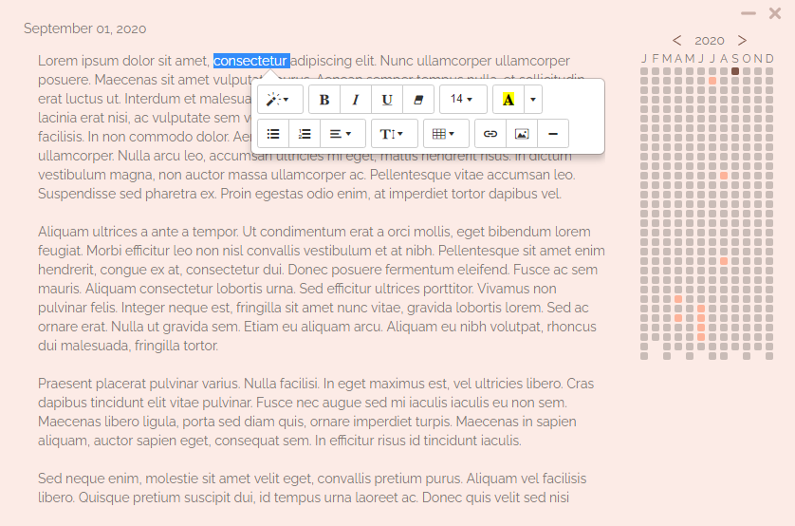

Notes on JRNL advanced text features:

1. If you want to copy text, select the text with your mouse and copy it with the standard Ctrl + C keyboard shortcut. This allows you to copy-and-paste text within JRNL or to copy text to paste into a different application. Paste using the standard Ctrl + V shortcut.
2. You need to select something — either text or a space — in order to activate the rich-text menu. For example, in order to insert an image or a table, you can use the spacebar to insert an empty space at the end of a sentence, select that space with your mouse, and then use the rich-text menu to insert the image or table.

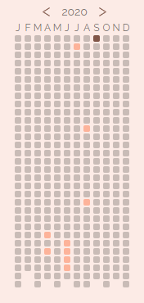**Using Hotkeys to Navigate Entries and Work with Text**

Once you have several days of journal entries, you may want to look at what you wrote yesterday, or a week ago, or even last Year. There are two ways you can navigate to previous entries. The first way is by using your mouse to select journal entry squares on the Calendar.

There are three different square colors on the Calendar. The currently selected day has one color; it should be the only square on the Calendar with that color. Other days with existing journal entries have a different square color. And days without any journal entries at all have a third square color. The Calendar shows squares for the entire year, organized in columns by month. Open an existing journal entry by clicking on the highlighted square in the Calendar or by using keyboard shortcuts (see below). Click on the left or right arrow next to the Calendar year to show a different year’s journal entries.

However, perhaps you don’t want to use your mouse. Nearly every action in JRNL is mapped to a hotkey (or keyboard shortcut). This allows you to write, navigate between journal entries, save entries, and hide JRNL without taking your hands away from the keyboard.

**Choosing entries**

Alt + Up arrow Open next earlier entry in current year’s Calendar

Alt + Down arrow Open next later entry in current year’s Calendar

Alt + Left arrow Open entry found to the left of the current entry in the current year’s Calendar

Alt + Right arrow Open entry found to the right of the current entry in the current year’s Calendar

Alt + Page Up Display the next year’s Calendar and entries

Alt + Page Down Display the prior year’s Calendar and entries

**Working within an entry**

Ctrl + X Cut the selected text or item

Ctrl + C Copy the selected text or item

Ctrl + V Paste the selected text or item

Ctrl + Z Undo the last action

Ctrl + A Select all text and items in the entry

Ctrl + Left arrow Move the cursor to the beginning of the previous word

Ctrl + Right arrow Move the cursor to the beginning of the next word

Ctrl + Down arrow Move the cursor to the next paragraph

Ctrl + Up arrow Move the cursor to the previous paragraph

Shift + arrow keys Select text within a paragraph or in the entry

**Save, Export, and Hide**

Ctrl + S Saves the current journal entry (unless it is empty)

Alt + Ctrl + Y Exports all entries for the currently displayed calendar year to a single, standalone html file (e.g., 2020.html) in the folder C:\Users\<current user>\Documents\JRNL Entries\

Esc By default, pressing the Esc key closes JRNL to the System Tray. (Closes JRNL completely if System Tray feature is disabled. See Advanced Configuration)

**Themes**

There are two additional hotkeys that allow you to view and choose between the JRNL themes. A theme determines the color of the JRNL text entry window and the colors of the day squares in the Calendar.

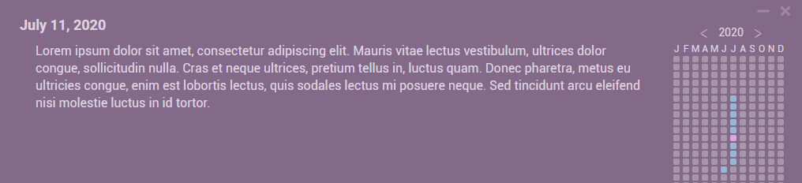

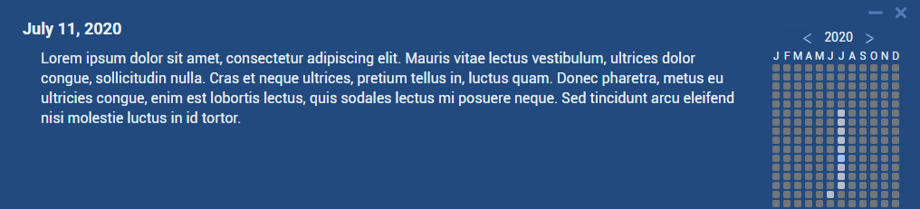

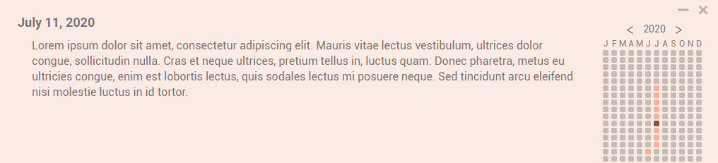

There are five pre-existing, built-in JRNL themes. You may tweak those themes or add new themes of your own by editing the configuration file (see Advanced Configuration: Themes).

Alt + = Show the next theme

Alt + - Show the previous theme

JRNL will remember the theme you’ve chosen and will use that theme until you choose another.

**Advanced Configuration: Changing the *config.json* file**

What if you want your daily notification to happen at 9:00 a.m. instead of 7:30 p.m.? What if you don’t want a notification at all? What if you want to change just the journal entry background color in your chosen JRNL theme? What if you want to make your own JRNL theme? These are a few of the JRNL features that can be personalized by changing settings within JRNL’s configuration file.

JRNL’s configuration file is *config.json.* This file is generated automatically within the JRNL install folder when JRNL is first run.

Many of JRNL's features can be personalized by editing the *config.json* file. The *config.json* file can be opened, edited, and saved using any text editor, such as Notepad or VSCode.

**In order to change the configuration file, you must first completely quit JRNL.** The easiest way to completely quit JRNL is to right-click on the JRNL icon in the System Tray and select Quit. Once you’ve quit JRNL, then you can use your text editor to open the *config.json* file in your JRNL install folder. Edit the appropriate parts of the file to change your settings and then save the file. Your new settings will be in place when you restart JRNL.

If for any reason the *config.json* file becomes unusable and JRNL won’t start, simply delete the *config.json* file from your JRNL install folder and then restart JRNL. JRNL will create a new *config.json* file. If you want to try again, remember to quit JRNL before reopening the new *config.json* file in your text editor.

The User Manual sections below describe in detail how to change different *config.json* settings.

**Advanced Configuration: Settings**

The "Settings" section of the *config.json* file contains several settings that you cannot otherwise change or customize from inside JRNL. **Reminder:** Completely quit JRNL before opening, editing, and saving the *config.json* file. Your new settings will be in place when you restart JRNL.

The following features can be disabled or modified as described.

"IsPastReadOnly": true, When set to *true,* previous journal entries can be viewed, but not modified. Change *true* to *false* to allow previous entries to be modified or to allow the creation of new entries on days where there are none in either the past or future. Leave the end comma in place.

"CloseToTray": true, When set to *true,* the X button at the top right corner of the JRNL window and the Esc hotkey will both hide JRNL by closing it to the System Tray. Change *true* to *false* to make those commands completely quit JRNL. Leave the end comma in place. (Note: Daily notifications are not sent unless JRNL is open either in the System Tray or on the Taskbar)

"DailyNotifications" This section contains several settings for daily notifications

"Enabled": true, When set to *true*, daily notifications are enabled. One notification is sent every day when the computer’s system time is the same as the "Time" setting below. JRNL must be open in the System Tray or on the Taskbar for this notification to be sent. Change *true* to *false* to disable notifications. Leave the end comma in place.

"Time": "07:30pm" This is the time when the daily notification will be sent. Change the time, following the format HH:MM<am/pm>.

"NotificationMessage": "Don't forget to add to your JRNL today!",

Change this text to change or personalize the daily notification message (e.g., “HEY, NIKKI! Have you written in your JRNL today? WHY NOT?”). Only change the text inside the quotation marks and leave the quotation marks and end comma in place.

It is advised that you not change the Hotkeys, CurrentTheme, or WindowBounds settings in the *config.json* file.

**Advance Configuration: Themes**

JRNL comes with a choice of five themes. You can create additional themes and add them to your copy of JRNL by copying an existing theme in the *config.json* file, pasting the copy into the array of themes, and then changing the hex colors for the different theme elements in the new theme copy. Once you have saved the *config.json* file and restarted JRNL, your new modified theme will be available. Just use the Alt + = or Alt + - hotkeys to flip through the themes until you find the one you created.

Each theme has this setting structure within the *config.json* file:

{

"base": {

"background-color": "#000000",

"color": "#ffffff"

},

"emptyDate": {

"background-color": "#dddddd"

},

"selectedEntry": {

"background-color": "#444444"

},

"unselectedEntry": {

"background-color": "#888888"

}

},

“base”

The two hex color entries in the "base" section determine the color of the JRNL entry window and the color of the text you type into that window. Change the hex color for “background-color” in the “base” section to change the window background color. Change the hex color for “color” to change the text color. Change only the hex color; leave the quotation marks intact on either side.

"emptyDate"

Change the hex color for “background-color” in the “emptyDate” section to change the color of the Calendar day squares that do not have a journal entry (i.e., the default color of day squares in the Calendar). These squares have no journal entries; either you didn’t write one or it’s for a date in the future.

"selectedEntry"

Change the hex color for “background-color” in the “selectedEntry” section to change the color of the currently selected day square in the Calendar. That is the square for today’s date when you open JRNL or the square for an entry in the past you have selected to view or edit.

"unselectedEntry"

Change the hex color for “background-color” in the “unselectedEntry” section to change the color of the day squares in the Calendar that do have existing entries, but are not the entry currently selected.